- Supplier interface
  - It is a functional interface that provides a get method to create something.
- To download a particular version of a library: https://mvnrepository.com/ this can be used.
  - Select the version you want to download.
  - Then select the build tool for which you need this. (in my case Maven)
- POM: Project Object Model
  - Every library contains 3 things:
    - Group id (it should be unique across the glove)
    - Artifact id
    - Version
  - 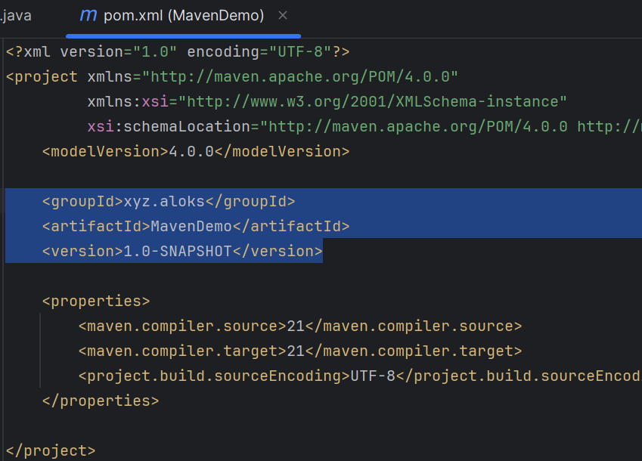
  - When I clicked on package (right side of intellij idea IDE), one .jar file got created.
    - MavenDemo-1.0-SNAPSHOT.jar
    - It contains the artifact id followed by the version.
  - Create one block <dependencies></dependencies> and paste all the dependency you want.
    - 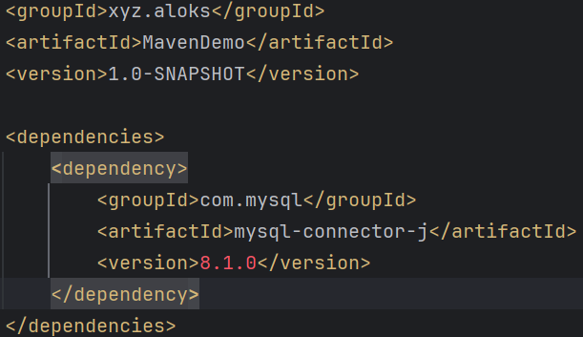
    - 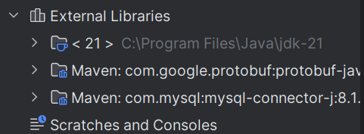
      - Now you can see, the myslql-connector got downloaded.
    - 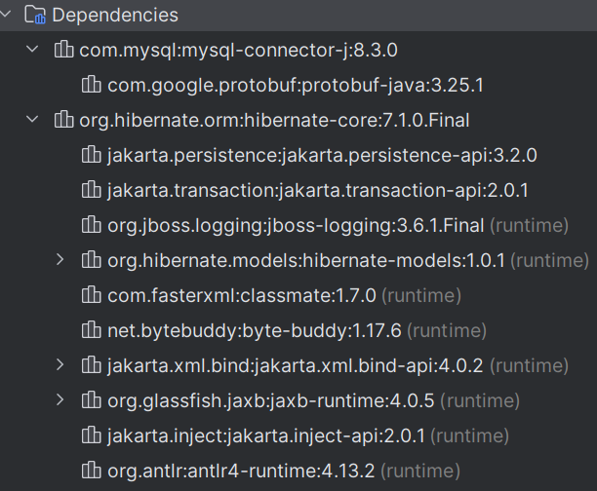
      - You can see the dependencies here.
      - For my-sql, only one .jar file got downloaded, but in case of hibernate, so may; it depends upon the package; every package needs its own set of dependencies.
  - If you want to add plugins, you can add.
  - NOTE:
    - Dependencies : the code needs to run; used at compile/run time
    - Plugins : tools/maven uses to build/manage; used at build time
  - But one thing is, Maven doesn’t see the pom.xml file, rather it sees the Effective POM file.
    - In intellij: right click on pom.xml file >> Maven >> Show effective pom

